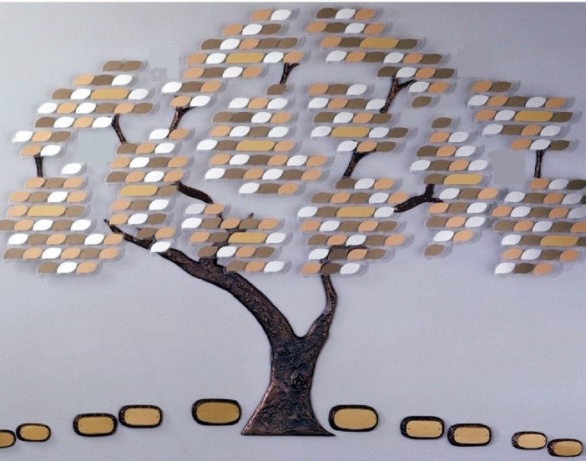

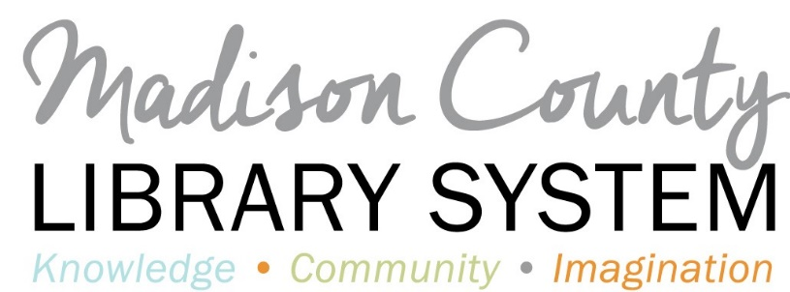

To make a donation in recognition, honor or memory of someone, simply choose a donor level then complete contact and engraving information.

|  |  |  |  |
| --- | --- | --- | --- |
| Donor Level | Amount | Benefit | Check One |
| Copper Donor | $100.00 | Engraved Copper Leaf (up to 50 characters and spaces) |  |
| Bronze Donor | $250.00 | Engraved Bronze Leaf (up to 50 characters and spaces) |  |
| Silver Donor | $500.00 | Engraved Silver Leaf (up to 50 characters and spaces) |  |
| Gold Donor | $1,000.00 | Engraved Gold Leaf (up to 50 characters and spaces) |  |
| Contributor | $2,500.00 | Engraved Foundation Stone (up to 75 characters and spaces) |  |
| Sponsor | $5,000.00 | Engraved Medium Foundation Stone (up to 75 characters and spaces) |  |
| Benefactor | $10,000 or more | Engraved Large Foundation Stone (up to 75 characters and spaces)  Name/Logo included on the bookmobile |  |

|  |  |  |
| --- | --- | --- |
| Sustainer | Already a donor? Become a Sustainer. Your additional donation helps sustain the programs and services of the MCLS. A clear crystal will be added to the sponsored leaf or stone to indicate sustainer status. |  |

Name Company

Address

City State Zip Code

Telephone number

Name to be engraved on leaf/stone

Include (choose one):

In Memory of

In Honor of

Name only

Please submit payment with form-make checks payable to Madison County Library System

102 Priestley Street, Canton, MS 39046